🌡 Temperature Monitor using DS18B20 & 16x2 I2C LCD

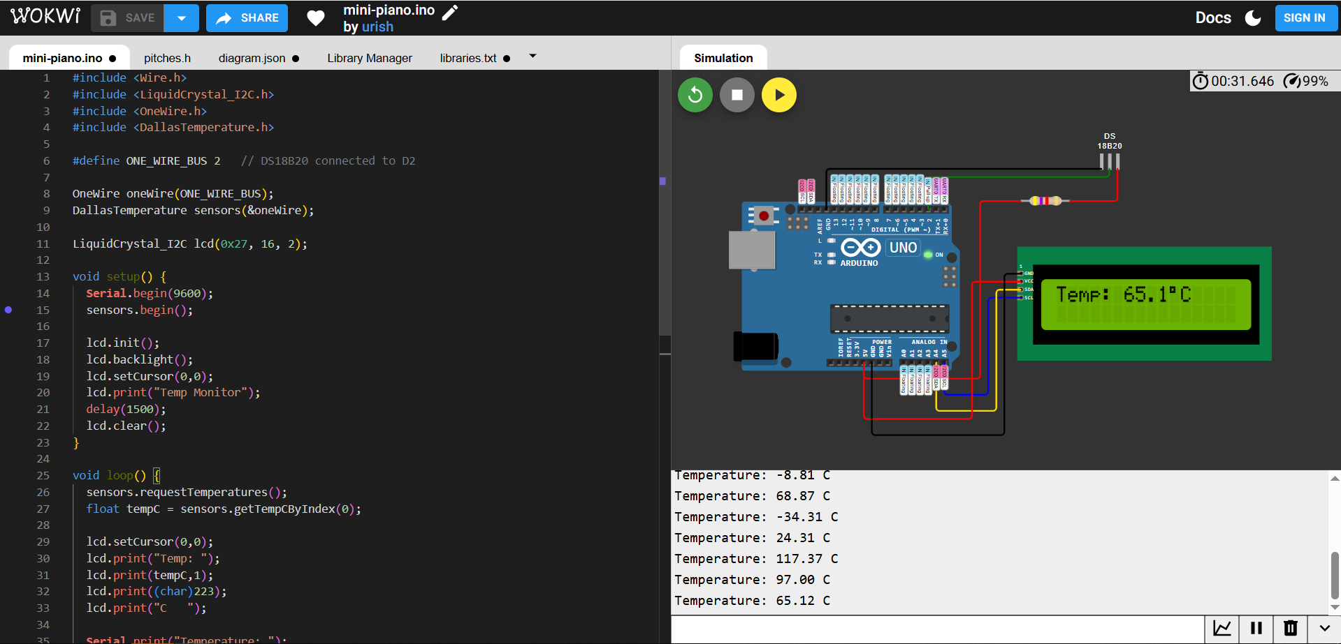

📌Task Overview
This project reads temperature from a DS18B20 digital sensor, displays the current temperature on a 16x2 I2C LCD, and logs the readings to the Serial Monitor.
The system uses 1-Wire communication to obtain accurate digital temperature readings and updates every second.

🧰 Components Used
- Arduino UNO
- DS18B20
- 16x2 I2C LCD (address 0x27)
- 4.7kΩ resistor (pull-up for DS18B20)
- Jumper wires

🔌 Wiring Diagram

🔹 DS18B20 Connections
DS18B20 Pin | Connect To
1 (GND) | GND
2 (DATA) | D2
3 (VCC) | 5V
⚠ Important:
Connect a 4.7kΩ resistor between D2 and 5V (pull-up resistor).

🔹 I2C LCD Connections
LCD Pin | Arduino UNO
VCC | 5V
GND | GND
SDA | A4
SCL | A5

⚙ How It Works
- The DS18B20 measures temperature digitally.
- Arduino communicates using the OneWire protocol.
- The temperature value is retrieved in Celsius.
- The value is:
  - Displayed on the 16x2 LCD
  - Printed to the Serial Monitor
- The system updates every 1 second.

💻 Arduino Code
#include <Wire.h>
#include <LiquidCrystal_I2C.h>
#include <OneWire.h>
#include <DallasTemperature.h>

#define ONE_WIRE_BUS 2 // DS18B20 connected to D2

OneWire oneWire(ONE_WIRE_BUS);
DallasTemperature sensors(&oneWire);

LiquidCrystal_I2C lcd(0x27, 16, 2);

void setup() {
Serial.begin(9600);
sensors.begin();

lcd.init();
lcd.backlight();
lcd.setCursor(0,0);
lcd.print("Temp Monitor");
delay(1500);
lcd.clear();
}

void loop() {
sensors.requestTemperatures();
float tempC = sensors.getTempCByIndex(0);

lcd.setCursor(0,0);
lcd.print("Temp: ");
lcd.print(tempC,1);
lcd.print((char)223);
lcd.print("C ");

Serial.print("Temperature: ");
Serial.print(tempC);
Serial.println(" C");

delay(1000);
}

